Memorandum

10/30/2020

|  |  |
| --- | --- |
| TO: | Chris Peery and Robert Wertheimer, U.S. Army Corps of Engineers |
| FROM: | Sam Haffey and Elliot Koontz, Four Peaks Environmental Science & Data Solutions |
| SUBJECT: | Lamprey Passage Analysis at The Dalles |
|  |  |

Lighting conditions at many adult fish count stations at the federally operated dams on the Columbia and Snake rivers need to be improved to support accurate fish counts. Fisheries observers have reported that it is difficult to identify species under current lighting conditions during both live and video counts. We have also observed that poor lighting is impacting the accuracy of the DNNCam, a computer vision system we have been testing to improve count accuracy and efficiency. The counting contract requires that Four Peaks provide the lighting necessary for fish counting.

On September 11, 2020, Four Peaks installed LED light bars along the bottom and side frames of the count window at The Dalles Dam, for both count stations (East and North ladders). The purpose of these lights was: (1) to improve lighting conditions for fishery observers completing live and video counts; and (2) to provide a consistent lighting environment for the proper operation of the DNNCam. Light bar installations include diffusers to spread the light evenly across the field of view and avoid bright spots that might disorient fish. This new lighting provides more even light than the floodlighting that has been the light source to date and should be less disorienting to fish. Furthermore, dimmer switches were installed on the new light bars, and lights are set to the lowest light setting.

The light bars at The Dalles operated continuously until approximately October 13, 2020. During this time, fisheries observers were instructed to report aberrant fish behavior that could be due to the light bars. The U.S. Army Corps of Engineers requested that the light bars on the bottom frame be turned off due to concerns that these lights may interfere with lamprey passage.

In response to these concerns, Four Peaks examined historical lamprey passage at The Dalles, reviewed fishery observer reports, and interviewed fishery observers to determine if there was an impact to lamprey passage caused by the light bars during the 2020 count season. The historical analysis (Attachment A) shows that daily lamprey passage was not significantly different with the light bars on than in previous years over the same dates. Additionally, fishery observers did not report aberrant behavior of fishes following light installation and remarked that the lighting improved visibility in the count window, making it easier to identify species and marks. The light bar installations also greatly improve the quality of video and the performance of the DNNCam, which has the potential to greatly improve the efficiency and accuracy of the U.S. Army Corps of Engineers adult fish counting program in future years.

We feel the light bars will improve the accuracy of fish count data and we request permission to continue using the light bars at The Dalles and other projects where our team is responsible for fish counts. Please contact me at 206.428.3077 extension 3 or [shaffey@fourpeaksenv.com](mailto:shaffey@fourpeaksenv.com) if you have any questions or would like to additional information on the lighting.

**Attachment A** **Historical Lamprey Passage at The Dalles, 2005-2020**

Attachment A Historical Lamprey Passage at The Dalles, 2005-2020

Daily Lamprey Passage Time Series

We examined annual lamprey passage at The Dalles Dam between September 15 and September 30 from 2005 through 2020. This provided a set window of time during which lights were continuously operated at The Dalles in 2020. For 2005 through 2018, adult passage daily ladder count data were queried from the Columbia River Data Access in Real Time (DART) website (DART 2020). For 2019, data were obtained from the database maintained by Four Peaks for the adult counting project. For each day in the period, the average amount of lamprey passage was computed across all 15 years of data available, and a 95% confidence interval for the average was constructed using a bootstrap method. These daily averages were then compared to lamprey passage observed in 2020, to determine if the observations fell substantially outside of the range of variability expected in daily count amounts based off the 2005-2019 results.

Results

Based on historical daily averages, it does not appear that lamprey passage was reduced overall by change to lighting conditions at The Dalles East or North ladders (Figure 1). Counts in lamprey totals generally decreased throughout this period, leading to decreased variability towards the end of the period compared to the beginning. At both ladders, 2020 counts between September 28 and 30 were below the historical average (95% confidence interval), but prior to these dates many 2020 counts were higher than the historical average. Towards the beginning of the period, 2020 observations were well within the range of the historical average from 2005-2019. Further analyses suggest that the total amount of lamprey passing during this period in 2020 falls well within the range of interannual variability observed from 2005 to 2019. Based on these results, it does not appear that that the LED light bars affected lamprey passage at The Dalles in 2020.

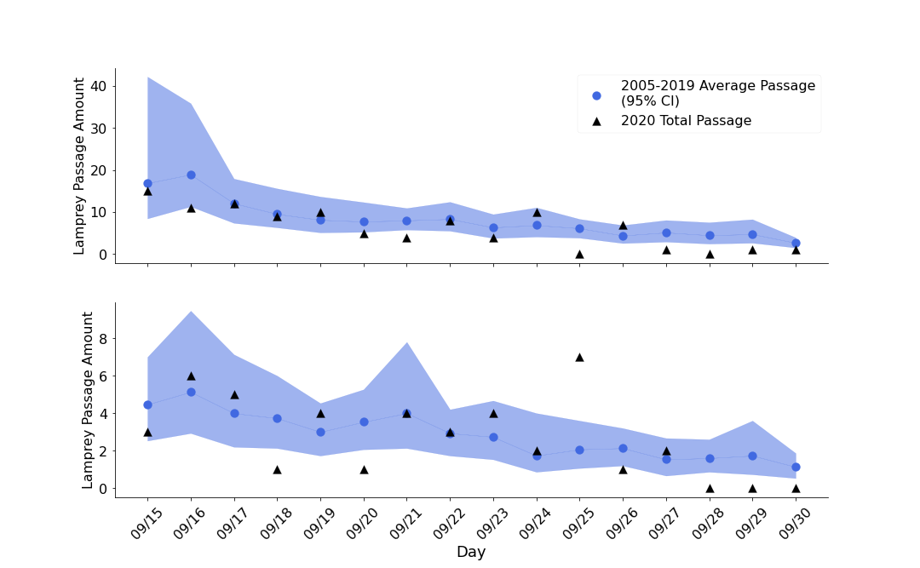

Figure 1. Time series for lamprey passage at The Dalles East (upper) and North (lower) ladders from September 15 to September 30 for 2005-2020. Blue lines represent historical daily averages and 95% confidence intervals from 2005-2019, while black triangles represent passage amounts observed in 2020.

References

DART (Columbia River DART, Columbia Basin Research, University of Washington). 2020. Adult Passage Daily Ladder Counts. Available at: <http://www.cbr.washington.edu/dart/query/adult_ladder_sum>.